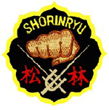
松
林
流

空手道
White Tiger Shorin-Ryu

M
a
t
s
u
b
a
y
a
s
h
i
-
R
y
u

K
a
r
a
t
e

-

D
o

In Association With The
European Matsubayashi-Ryu
Karate-Do Association

Are Proud To Present An Open Seminar With The
Hereditary Grandmaster Of Matsubayashi-ryu
Soke Takayoshi Nagamine
10th Dan, Hanshi-sei
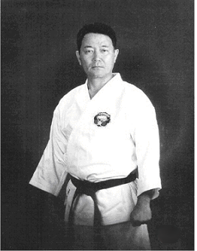

Saturday, 17th July, 2010

White Tiger Martial Arts
McHale Road Business Park, Castlebar, Co. Mayo, Ireland

Reg: 12 noon Seminar: 12.30 pm To 2 pm Fee: €15

For More Information Contact Martin At 087 – 6407263

